Yorkshire Regional General Gymnastics Competitions Floor and Vault competition
Boys
Skills and Tariff sheet – Introductory to Advanced+ Levels
Requirements – Floor and Vault
 |  | Introductory Level | Intermediate Level | Advanced Level | Advanced+ Level
Key Information |  | - Equipment dimensions/type can be found within the handbook
Floor Information |  | - 10 elements are required  - All holding elements are to be held for two ‘Mississippi’ (or similar choice of wording)
 |  |  |  | - Bonus can be added to the DV score  - Two bonus per routine permitted | - Bonus can be added to the DV score  - Two bonus per routine permitted
Vault Information |  | - Vault height as per handbook, warm up vault must suit the group  - Two attempts permitted on vault, best score to count
 |  | - Bonus given for a layout vault showing a full horizontal layout
Difficulty Value  (DV score) | Floor | - Each Element is valued at 0.1  - Max DV score = 1.0  - Additional Elements performed don’t count towards DV score but may incur Execution Deductions (unless stated as a bonus – Adv & Adv+ Level only)  - Bonus are added to the DV score
 | Vault | - This is listed next to the skill within the Skills section of this document  - Bonus added to DV score
Compositional Score  (C score) | Floor | - For each ‘Category’ selected a value of 0.5 is added to the C score  - Max C score = 2.5  - At least 1 Element to be selected from each Category  - Elements selected from the ‘Other skills’ section don’t count towards an ‘Category’ but do count towards your total element count
 | Vault | - This is not required in this part of the competition
Execution Score  (E score) |  | - Scored out of 10.0  - See deduction table included within this document for guidance of the type of Execution Deductions judges will make
Scoring Information |  | - Difficulty Valve (DV score) + Compositional Score (C score) + Execution Score (E score) = Starting Score  - Starting Score – Judges Execution Deductions = Final Score

Skills – Floor
Category | Introductory Level | Intermediate Level | Advanced Level | Advanced+ Level
Forwards  (Min of 1) | - Forwards roll to stand (1 or 2 legs at a time)  - Forwards roll to sit (tuck or straddle)  - Forwards roll to straddle stand  - Handstand tucked (high bunny jump)  - Handstand  - Swedish fall (2 sec)  - Jump forwards roll | - Forwards roll to stand (1 or 2 feet)  - Forwards roll to sit (straddle)  - Forwards roll to straddle stand  - Handstand  - Swedish fall  - Handstand forwards roll (bent or straight arms)  - Dive forwards roll | - Forwards roll to stand (1 or 2 feet)  - Forwards roll to straddle stand  - Forwards roll to stand (straight arms and legs)  - Handstand  - Handstand forwards roll (straight arms)  - Handspring (to 2 or 1 feet)  - Flyspring  - Swedish fall  - Dive forwards roll  - Swallow dive roll | - Forwards roll to stand (1 or 2 feet)  - Forwards roll to straddle stand  - Forwards roll to pike (straight arms and legs)  - Handstand  - Handstand forwards roll (straight arms)  - Healey handstand  - Handstand Pirouette (min ½ up to 1/1)  - Handspring (to 2 or 1)  - Headspring  - Flyspring  - Swedish fall  - Dive forwards roll  - Forwards somersault (tucked) - sprung floor permitting
Backwards  (Min of 1) | - Backwards roll to stand (tuck, straddle, pike, or front support)  - Shoulder roll  - Rock to stand  - Shoulder stand then rock to stand | - Backwards roll to stand (tuck, straddle, pike, or front support)  - Backwards roll with straight arms and legs | - Backwards roll to stand (tuck, straddle, pike, or front support)  - Backwards roll with straight arms and legs  - Backwards roll to handstand (bent or straight arms)  - Jump ½ turn to front support  - Flic to 1 or 2 feet | - Backwards roll to stand (tuck, straddle, pike, or front support)  - Backwards roll with straight arms and legs  - Backwards roll to handstand (bent or straight arms)  - Jump ½ turn to front support  - Flic (to 2 feet)  - Backwards somersault (tucked) – Sprung floor permitting
Sideways  (Min of 1) | - Log roll  - Egg roll tucked  - Dish  - Arch  - Side roll with knees passing through straddle  - 180° Teddy bear roll  - Cartwheel | - Dish hold  - Arch hold  - Dish roll to arch  - Side roll with knees passing through straddle  - 180° Teddy bear roll  - Cartwheel side to side  - Cartwheel ¼ in/out  - Round off | - Dish roll to arch hold  - Side roll to knee  - Cartwheel  - Cartwheel ¼ in/out  - Round off  - Tinsica  - Free Cartwheel (no run permitted) | - Dish roll to arch hold  - Side roll to knee  - Cartwheel  - Cartwheel ¼ in/out  - Round off  - Tinsica  - Free Cartwheel (no run permitted)  - Side Somersault (sprung floor permitting)

Skills – Floor (continued)
Category | Introductory Level | Intermediate Level | Advanced Level | Advanced+ Level
Flight  (Min of 1) | - Jumps (straight, star, tuck, ½ turn, or 1/1 turn)  - Leaps (scissor kick, cat)  - Single leg circle | - Jumps (tuck, star, straddle, ½ turn, or 1/1 turn)  - Leaps (scissor kick)  - Single leg circle | - Jumps (tuck, straddle, ½ turn, 1/1 turn, tuck ½ turn)  - Leaps (scissor kick)  - Single leg circle | - Jumps (tuck, straddle, ½ turn, 1/1 turn, tuck ½ turn)  - Leaps (scissor kick)  - Single leg circle
Balance  (Min of 1) | - V sit (with or without aid of arms)  - Supports (front or back)  - Straddle sit  - Single leg balance  - ½ Lever (one leg on floor)  - Frog balance  - Headstand tucked  - Lever (tucked) | - V sit (with or without aid of arms)  - ½ Lever (pike or straddle)  - Single leg balance  - Headstand straight legged  - Lever (tucked) | - V sit (without aid of arms)  - ½ Lever (pike or straddle)  - Handstand  - Headstand push to handstand  - Elephant lift held  - Single leg balance  - Lever (tucked) | - V sit (without aid of arms)  - ½ Lever (pike or straddle)  - Handstand  - Headstand push to handstand  - Elephant lift held  - Single leg balance  - Lever (tucked)  - Russian lever
 | - Splits (any)  - Japana (chest on floor or swim through)  - Bridge  - D balance | - Splits (any)  - Japana (chest on floor or swim through)  - Bridge  - D balance | - Splits (any)  - Japana (chest on floor or swim through)  - Bridge  - D balance  - Chest balance (fish) | - Splits (any)  - Japana (chest on floor or swim through)  - Bridge  - D balance  - Chest balance (fish)

Other skills | - Side support | - Front support walk through side support to back support (positions not held) | - Front support walk through side support to back support (positions not held)  - Press up | - Front support walk through side support to back support (positions not held)  - Press up  - Flare

Bonus  (Max of 1.0 )  *Extra info on page 8 |  |  | - Linking of two acrobatic tumbling elements with flight = 0.5  - Linking of two jumps in a series = 0.5 | - Linking of two acrobatic tumbling elements with flight= 0.5  - Linking of two jumps in a series = 0.5

Deductions – Floor
Deductions |  |  | 0.1 | 0.3 | 0.5 | 1.0
Execution Score  (E score) Max of 10.0 | Artistry deduction | Insufficient flow/dynamics of routine | X | X | X
 | throughout
 |  | Touch of hair/leotard/clothing | X
 | Specific floor deductions | Prompting by coach (first occurrence) |  | X
 |  | Prompting by coach (further occurrences) (max 1.0) | X
 |  | Missing competition requirements |  |  | X
 |  | No presentation | X
 | Skill focused deductions (Each time) | Bent arms or bent knees | X | X | X
 |  | Leg or knee separation | X | X
 |  | Insufficient height of element | X | X
 |  | Insufficient tuck, pike or stretch | X | X
 |  | Brush against apparatus |  | X
 |  | Instability/wobble/adjustment in element | X | X
 |  | Balance Element not held for two seconds |  |  | X
 |  | Feet not pointed/loose/body alignment | X
 |  | Lack of rotation on turns & acro skills | X | X
 |  | Backwards roll with 2 point contact |  | X
 | Landing  deductions  (Each time) | Landing from tumbles (step) | X | X
 |  | Trunk movement to maintain balance | X | X
 |  | Extra steps up to 0.5 | X
 |  | Very large step or jump |  | X
 |  | Deep squat |  |  | X
 |  | Stepping off the floor area (1 foot) | X
 |  | Stepping off the floor area (2 feet) |  | X
 | Falls  (Each skill) | 2nd attempt of balance element |  |  | X
 |  | Falls |  |  |  | X

Deductions |  |  | 0.1 | 0.3 | 0.5 | 1.0
 | DV score | Missing elements (max 1.0) | X
Head Judge Deductions  (Create DV score and C | Categories covered (Up to 2.5) | Forwards (max 0.5) |  |  | X
 |  | Backwards (max 0.5) |  |  | X
 |  | Sideways (max 0.5) |  |  | X
 |  | Flight (max 0.5) |  |  | X
 |  | Balance (max 0.5) |  |  | X
score)
 | Bonus | Performance of bonus element (0.5 per |  |  | X
 | (Adv and Adv+ Level only) | element)

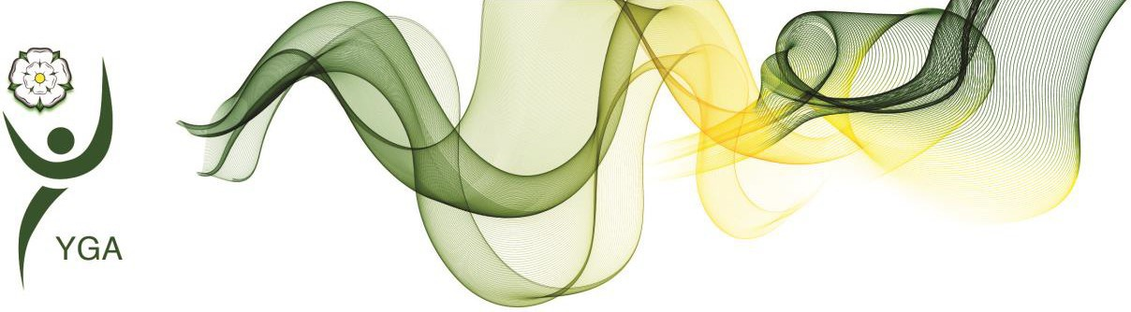

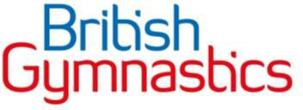

Skills/Tariffs – Vault
Vault |  | DV score
 |  | Introductory Level | Intermediate Level | Advanced Level | Advanced+ Level
1 | Squat on | 1.0 | 1.0 | 1.0 | 1.0
2 | Straddle on | 1.0 | 1.0 | 1.0 | 1.0
3 | Straight jump on to block – jump off (straight/tuck/star) | 1.0 | 1.0 | 1.0 | 1.0
4 | Squat through | 2.0 | 2.0 | 2.0 | 2.0
5 | Straddle over | 2.0 | 2.0 | 2.0 | 2.0
6 | Layout squat vault | 2.0 | 2.0 | 2.0 | 2.0
7 | Layout straddle vault | 2.0 | 2.0 | 2.0 | 2.0
8 | Straight jump up – handstand fall onto level mats | 1.5 | 1.5 | 1.5 | 1.5
9 | Straight jump up – round off dismount |  | 2.0 | 2.0 | 2.0
10 | Handstand flatback |  | 2.5 | 2.5 | 2.5
11 | Straight jump up – handspring dismount onto lower mats |  |  | 3.0 | 3.0
12 | Handspring stand up onto level mats |  |  | 3.5 | 3.5
13 | Handspring |  |  | 4.0 | 4.0
14 | Handspring 1/2 on or Handspring 1/2 off |  |  |  | 4.0
Bonus of 1.0 to be added to the DV score when a layout vault is shown with a full horizontal layout shape.
Deductions – Vault

Deductions |  | 0.1 | 0.3 | 0.5 | 1.0
First flight | Incomplete turn | X | X | X
 | Hip angle | X | X
 | Bend knees | X | X | X
 | Leg separation | X | X
 | Arch | X | X
 | Insufficient layout in squad/ straddle | X | X | X
Repulsion | Staggered altered hand placement | X | X
 | Bent arms | X | X | X
 | Shoulder angle | X | X
 | Touch with one hand |  |  |  | X
 | Failure to pass through vertical |  | X
Second flight | Lack of height | X | X | X | X
 | Incomplete turn | X | X
 | Insufficient length | X | X | X
 | Bent knees | X | X | X
 | Leg separation | X | X
Landing | Extra steps (each) | X
 | Large steps (over shoulder width) |  | X
 | Extra arm swing | X
 | Additional trunk movement | X | X
 | Body posture faults | X
 | Deep Squat |  |  | X
 | Deviation from center | X
 | Brush on apparatus |  |  | X
 | Step off landing mat 1 foot | X
 | Step off landing mat 2 feet |  | X
 | Fall |  |  |  | X
Additional | Double bounce on springboard |  |  |  | X
 | Skill attempted but not completed |  |  | X
 | Skill not attempted at all |  |  |  | X
 | Support from coach |  |  |  | X
 | No presentation | X

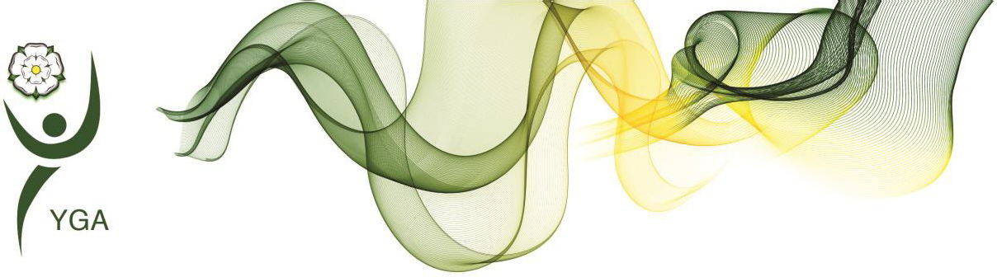

Apparatus

The following equipment and apparatus will be used for these competitions:

Apparatus | Specific use for | Manufacturer | Size, dimensions, run up,  landing details | Image
Floor | All levels | Contact venue for specifics | Min = 10m x 8m | Images to follow on completion of registration
Box vault (cross)  [*Traditional Vault type] | All Levels  Vault selections: 1, 2, 4, and 5 | Contact venue for specifics | Heights: Under 8’s = 0.8m Under 10’s = 0.9m Under 12’s = 1.0m Over 13’s = 1.1m –  1.2m  Landing: 0.3m thick safety mat | Images to follow on completion of registration
Vault  [*Inverted Vault type] | All Levels  Vault selections: 3 | Contact venue for specifics | Heights:  All ages = 0.6m  Landing: 0.3m thicksafety mat | Images to follow on completion of registration
Box vault (cross or long)  [*Traditional Vault type] | All Levels  Vault selections: 6 and 7 | Contact venue for specifics | Heights: Under 8’s = 0.8m Under 10’s = 0.9m Under 12’s = 1.0m Over 13’s = 1.1m –  1.2m  Landing: 0.3m thick safety mat | Images to follow on completion of registration
Vault with level mats  [*Inverted Vault type] | All Level  Vault selection: 8 | Contact venue for specifics | Heights:  All ages = 0.6m | Images to follow on completion of registration
Vault  [*Inverted Vault type] | Intermediate,  Advanced and Advanced+ Level  Vaults selection: 9 | Contact venue for specifics | Heights:  All ages = 0.6m  Landing: 0.3m thick safety mat | Images to follow on completion of registration

Vault with level mats  [*Inverted Vault type] | Intermediate, Advanced and  Advanced+ Level  Vaults selections: 10 | Contact venue for specifics | Heights: Under 8’s = 0.6m Under 10’s = 0.6m Under 12’s = 0.9m Over 13’s = 0.9m | Images to follow on completion of registration
Vault with safety landing mat at the end  [*Inverted Vault type] | Advanced and Advanced + Levels  Vault selections: 11 | Contact venue for specifics | Heights:  All Ages = 0.6m  Landing: 0.3m thick safety mat | Images to follow on completion of registration
Vault with level mats  [*Inverted Vault type] | Intermediate, Advanced and  Advanced+ Level  Vault selections: 12 | Contact venue for specifics | Heights: Under 8’s = 0.6m Under 10’s = 0.6m Under 12’s = 0.9m Over 13’s = 0.9m | Images to follow on completion of registration
Vault  [*Inverted Vault type] | Advanced and  Advanced + Levels  Vault selection 13 and 14 | Contact venue for specifics | Heights: Under 8’s = 0.6m Under 10’s = 0.6m Under 12’s = 0.9m Over 13’s = 0.9m Landing: 0.3m thick  safety mat | Images to follow on completion of registration
If you have any specific questions regarding the apparatus, please contact the Competition Organiser.

Notes:
- ‘Vault selections’ can be found on the ‘Skills and Tariff sheets’

- *Vault type definitions:

  - Traditional – Layered, Wooden school, Box vaults
  - Inverted – Block, Block with mat, Table, Soft table, Horse vaults

- When using traditional style vaults (box, layered, wooden style school vaults etc.)please allow for + / - 5 cm of the stated vault height.

- Coaches can request for vault heights to be increased than stated heights. Heights can’t be lower than stated measurements.

Deductions
You will find general deductions in the ‘Skills and Tariff Sheets’ accompanying this handbook.

*Extra bonus information

Linking of two acrobatic tumbling elements with flight
Listed below are different variations of linking two acrobatic tumbling elements with flight, it is still open for coaches to do other variations but keep in mind the definition below with what skills with flight means.

"a skill where the gymnast is suspended completely in the air without their hands or any other part of their body touching the floor"

· Front handspring, flyspring
· Front handspring to 1, front handspring to 2
· Front handspring to 1, round off
· Round off, Back handspring
· Front somersault walkout, round off
· Handspring, front somersault
· Round off, Back somersault
· Back handspring to 2, back handspring to 1
· Back handspring to 1, back handspring to 2
· Free cartwheel, back handspring
· Free walkover, back handspring

Linking of two jumps in a series
The linking of two jumps in a series should be picked from the flight category and they should be linked immediately. E.g. Star jump, rebound into a tuck jump.

