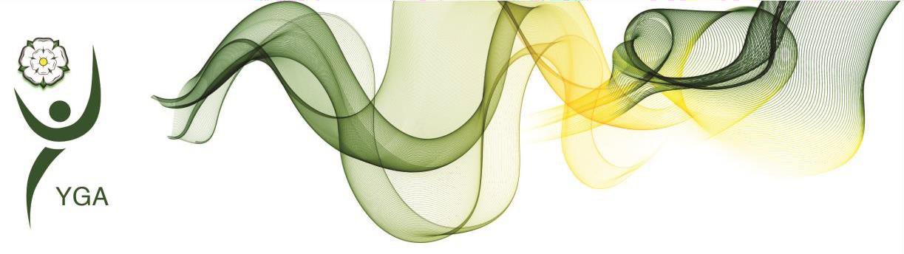

Yorkshire Regional General Gymnastics Competitions 4 Piece Competition – **DIAMOND LEVEL**

Girls

Skills and Tariff sheet V1.01

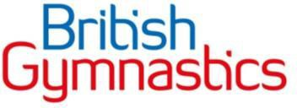

|  |  |  |  |
| --- | --- | --- | --- |
| Key Information | | * Equipment dimensions can be found in the handbook * Only permitted elements are allowed, and no Difficulty Value will be given for non-permitted elements if they are performed. * IMPORTANT – At all levels, coaches and gymnasts should concentrate their efforts towards the accuracy of technical execution. | |
| Floor Information | | * 8 elements are required * Ideally should include 4 Compositional requirements (CR) * Only permitted elements allowed * All holding elements are to be held for two ‘Mississippi’ (or similar choice of wording * Music length is required between 45’s-1min 15secs. * Longer music maybe used (max 1min 30secs) without a penalty but is not to be encouraged. Music longer than 1min 30secs will incur a penalty | Bonus |
| * Advanced dance element 0.2 * Salto forwards or backwards in Acro line 0.2 * Good use of directions, levels, and corners 0.3 * Bonus can be added to DV |
| Beam Information | | * 8 elements are required (including mount & dismount) * Ideally should include 4 Compositional requirements (CR) * All holding elements are to be held for two ‘Mississippi’ (or similar choice of wording | * Exercise without a fall 0.5 [provided all CRs are fulfilled] * 2 Acro skill linked to Salto dismount 0.2 |
| * Beam Height 125cm |
| * Matting to sit under the beam - 20cm with additional 10cm at dismount |
| Bar Information | | * 6 elements are required * Ideally should include 4 Compositional requirements (CR) | * Cast to Handstand 0.3 * Exercise with no stops 0.2 * Stationery landing 0.2 |
| Vault Information | | * Vault height as per handbook, warm up vault to suit the group * Two attempts permitted on vault, best score to count |  |
| **Difficulty Value**  (DV Score) | Floor | * Each element permitted elements) is valued at 0.1 | Advanced dance elements are valued at 0.2 and are counted as bonus * Max DV score = 0.8 * Additional Elements performed don’t count towards DV score but may incur Execution Deductions * Bonus are added to the DV score | |
| Beam | * Each element is valued at 0.1 * Max DV score = 0.8 * Additional Elements performed don’t count towards DV score but may incur Execution Deductions * Bonus are added to the DV score | |
| Bar | * Each element is valued at 0.1 * Max DV score = 0.6 * Additional Elements performed don’t count towards DV score but may incur Execution Deductions * Bonus are added to the DV score | |
| Vault | * This is listed next to the vault skill on the criteria sheet * Bonus are added to the DV score | |
| **Compositional Score**  (C Score) | Floor | * For each Composition requirement (CR) selected, a value of 0.5 is added to the C Score. * Max C score = 2.0 * Choose 4 Compositional requirements (CR) for the list on the skills list. | |
| Beam | * For each Composition requirement (CR) selected, a value of 0.5 is added to the C Score. * Max C score = 2.0 * Choose 4 Compositional requirements (CR) for the list on the skills list. | |
| Bar | * For each Composition requirement (CR) selected, a value of 0.5 is added to the C Score. * Max C score = 2.0 * Choose 4 Compositional requirements (CR) for the list on the skills list. | |
| Vault | This is not required in this part of the competition. | |
| Execution Score (E score) | | * Scored out of 10.0 * See deduction table included within this document for guidance of the type of Execution Deductions judges will make | |
| SCORING INFORMATION | | * Difficulty Value (DV score) + Compositional Score (C score) + Execution Score (E score) = Starting score * Starting score – Judges Execution Deductions = Final Score | |

** **

**DIAMOND 4 PC**

**COMPTITION CRITERIA (updated June 2023)**

**Age groups (in year of the competition) 9 & 10, 11 & 12, 13’s+**

|  |  |  |  |
| --- | --- | --- | --- |
| **Vault** | Handspring - 13.00  Yamashita Vault – 13.50  ½ on , ½ off – 13.50 | **Vault Heights**  90 cm aged 9 & 10, 11 & 12 (min) - Using Blocks or firm mats as alternative to table vault if preferred  Higher level vaults permitted using Table vault for all age groups | 2 x vaults permitted  Vaults may be different  Best score to count |
|  | **Permitted Elements**  **0.1 each** | **(CR’s) - Composition Requirements 4 x0.5 each** | **Bonus Options** |
| **Bars** | **Mounts**  Upward circle from two feet, Float upstart, Jump ½ turn float upstart, Jump to hands on high bar float upstart, Jump to high bar with full turn, Straddle vault over LB to catch HB  Float swing, cast towards horizontal, counter swing, Long Float upstart,  Forward hip circle, back hip circle, Squat on LB, ¾ giant from LB to HB,¾ giant from HB to HB, Clear back hip circle, Sole circle, Cast to handstand  **Dismounts**  Straddle/ Pike undershoot (with or without ½ turn) | 1. Float upstart 2. Long Float upstart LB to HB 3. Close bar element 4. Different additional close bar element 5. Cast to 45* as part of element 6. Dismount | Cast to handstand (straddle/pike or straight)  **0.3**  Exercise without stops  **0.2**  Stationary landing  **0.2** |
| **Beam** | **Mounts**  Japana, Squat/stoop through to rear support, Cartwheel/stand at side of the beam with bending of both arms jump to Chest stand to swing down, Jump to handstand with bent or straight arms  Straight jump, tuck jump, cat leap,½ spin, ½ spin into ½ turn, Full spin  Forward roll to feet, backwards roll to feet, Cartwheel, Arabesque, Y-balance, Lever hold (straddle or pike) splits hold, Needle scale, Handstand hold  Stag jump, split jump, Wolf jump, Stag leap, split leap, wolf hop, Scissor kick, Sissonne  Backwards walkover, Forwards walkover, Tick-tock  **Dismounts**  Round off, Handspring, Cartwheel into straight jump, Back Salto, Front Salto, Free Roundoff | 1. Full spin 2. 2 Jumps or leap/jump connection (joined) 3. Acro element forward or sideways 4. Acro element backwards 5. Split jump / Split leap 6. Acro skill linked to Salto dismount | Exercise without a fall **0.5**  (provided all CR’s are fulfilled)  Acro series  **0.2** |
| **Floor** | Straight jump, tuck jump, star jump, split jump, Wolf jump, Full turning jump, Full spin, Cat leap, Scissor kick leap, Split leap, Wolf hop, Sissonne, Fouetté Hop  Forward roll (optional exit to feet), Backwards roll (optional exit to feet), Handstand (from jump, kick or press), Handstand forward roll, Backwards roll to handstand, cartwheel, Round-off, Forward walkover, backwards walkover, Tick-tock, Tinsica,  Handspring to one, Handspring to two, Fly spring, Back flip, Free Cartwheel, Free Walkover, Front Salto, Back Salto  **Advanced Dance** - Split jump ½ turn, Straddle jump ½ turn, Wolf jump ½ turn, Full turning cat leap, Full turning wolf hop, Change leg split leap, Johnson Leap | 1. Dance passage of 2 leaps 2. Acro element forward or sideways 3. Acro element backwards 4. Spin 360 degrees or jump full turn 5. Mixed series 6. Acro line of 2 or 3 elements | Acro line with Salto  **0.2**  Advanced dance element  **0.2**  Good use of direction, levels and corners  **0.3** |