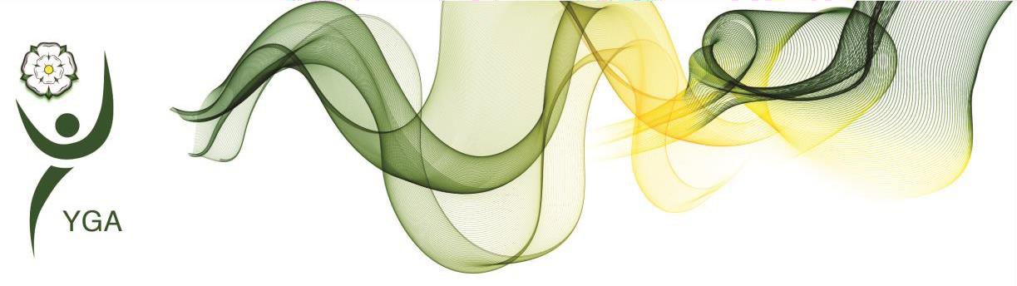

Yorkshire Regional General Gymnastics Competitions 4 Piece Competition - **CRYSTAL**

Girls

Skills and Tariff sheet

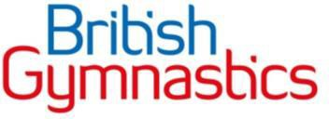

|  |  |  |  |
| --- | --- | --- | --- |
| Key Information | | * Equipment dimensions can be found in the handbook * Barred elements are not allowed, and no Difficulty Value will be given if they are performed. * IMPORTANT – At all levels, coaches and gymnasts should concentrate their efforts towards the accuracy of technical execution. | |
| Floor Information | | * 8 elements are required * Ideally should include 4 Compositional requirements (CR) * Only permitted elements allowed * All holding elements are to be held for two ‘Mississippi’ (or similar choice of wording * Music length is required between 45’s-1min 15secs. * Longer music may be used (max 1min 30secs) without a penalty but is not to be encouraged. Music longer than 1min 30secs will incur a penalty | Bonus |
| * Split leap showing 180* element 0.2 * Salto forwards or backwards 0.2 * Good use of directions, levels, and corners 0.2 * Bonus can be added to DV |
| Beam Information | | * 8 elements are required (including mount & dismount) * Ideally should include 4 Compositional requirements (CR) * All holding elements are to be held for two ‘Mississippi’ (or similar choice of wording | * Exercise without a fall 0.5 [provided all CRs are fulfilled] * Split jump or split leap 0.2 |
| * Beam Height 125cm |
| * Matting to sit under the beam may be applied for younger gymnasts |
| Bar Information | | * 6 elements are required * Ideally should include 4 Compositional requirements (CR) | * Cast to 45° or above **or** Float upstart 0.3 * Exercise with no stops 0.2 * Stationery landing 0.2 |
| Vault Information | | * Vault height as per handbook, warm up vault to suit the group * Two attempts permitted on vault, best score to count |  |
| **Difficulty Value**  (DV Score) | Floor | * Each element (permitted skills) is valued at 0.1 * Max DV score = 0.8 * Additional Elements performed don’t count towards DV score but may incur Execution Deductions * Bonus are added to the DV score | |
| Beam | * Each element is valued at 0.1 * Max DV score = 0.8 * Additional Elements performed don’t count towards DV score but may incur Execution Deductions * Bonus are added to the DV score | |
| Bar | * Each element is valued at 0.1 * Max DV score = 0.6 * Additional Elements performed don’t count towards DV score but may incur Execution Deductions * Bonus are added to the DV score | |
| Vault | * This is listed next to the vault skill on the criteria sheet * Bonus are added to the DV score | |
| **Compositional Score**  (C Score) | Floor | * For each Composition requirement (CR) selected, a value of 0.5 is added to the C Score. * Max C score = 2.0 * Choose 4 Compositional requirements (CR) for the list on the skills list. | |
| Beam | * For each Composition requirement (CR) selected, a value of 0.5 is added to the C Score. * Max C score = 2.0 * Choose 4 Compositional requirements (CR) for the list on the skills list. | |
| Bar | * For each Composition requirement (CR) selected, a value of 0.5 is added to the C Score. * Max C score = 2.0 * Choose 4 Compositional requirements (CR) for the list on the skills list. | |
| Vault | This is not required in this part of the competition. | |
| Execution Score (E score) | | * Scored out of 10.0 * See deduction table included within this document for guidance of the type of Execution Deductions judges will make | |
| SCORING INFORMATION | | * Difficulty Value (DV score) + Compositional Score (C score) + Execution Score (E score) = Starting score * Starting score – Judges Execution Deductions = Final Score | |

** **

**CRYSTAL 4 PC**

**COMPETITION CRITERIA (updated June 2023)**

**Age groups (in year of the competition) 7 & 8, 9 & 10, 11 & 12, 13’s+**

|  |  |  |  |
| --- | --- | --- | --- |
| **Vault** | Handspring to Flat Back – 2.5  Handspring up onto Mats – 3.00  Handspring - 3.5 | **Vault Heights**  60 cm aged 7 &8, 9 & 10 (min)  (Using Blocks or firm mats)  90 cm aged 11+ (min)  (Using Blocks or firm mats)  Higher level vaults permitted using Table vault if preferred | 2 x vaults permitted  Vaults may be different  Best score to count |
|  | **Permitted Elements**  **0.1 each** | **Composition Requirements (CR’s)**  **4 x 0.5 each** | **Bonus Options** |
| **Bars** | **Mounts**  Upward circle from two feet, Float upstart, Jump ½ turn float upstart, Jump to hang on high bar float upstart  Float swing, cast towards horizontal, counter swing, Long Float upstart, Forward hip circle, back hip circle, Squat on LB, ¾ giant from LB to HB,¾ giant from HB to HB  **Dismounts**  Straddle/ Pike undershoot (with or without ½ turn dismount) | 1. Upward circle from 2 feet 2. Backwards hip / forward hip circle 3. Element to HB 4. Element started and finished on HB 5. Dismount | Cast to 45 or above **OR** float upstart  **0.3**  Exercise without stops  **0.2**  Stationary landing  **0.2** |
| **Beam** | **Mounts**  Squat on, Straddle on, Japana, Squat/stoop through to rear support  Straight jump, tuck jump, cat leap, ½ spin, ½ spin into ½ turn, full spin,  Forward roll to feet, backwards roll to feet, Cartwheel, Arabesque, Y-balance, Lever hold (straddle or pike) splits hold, Needle Scale, Handstand Hold  Stag jump, split jump, Wolf jump  Stag leap, split leap, wolf hop, Scissor kick, Sissonne  Backwards walkover, Forwards walkover, Tick-tock  **Dismounts**  Round off, Handspring, Cartwheel into straight jump, Back Salto, Front Salto, | 1. ½ spin into immediate ½ turn 2. 2 Jumps or leap/jump connection (joined) 3. Acro element forward or sideways 4. Acro element backwards 5. Mixed series 6. Salto Dismount | Exercise without a fall **0.5**  (provided all CR’s are fulfilled)  Split Jump or leap  **0.2** |
| **Floor** | Straight jump, tuck jump, star jump, split jump, Wolf jump, Full turning jump, Full spin  Cat leap, Scissor kick leap, Split leap,  Wolf hop, Fouette Hop, Sissonne  Forward roll (optional exit to feet), Backwards roll (optional exit to feet), Handstand (from jump, kick or press), Handstand forward roll, Backwards roll to handstand, Cartwheel, Roundoff, Forward walkover, backwards walkover, Tick-tock, Tinsica,  Handspring to one, Handspring to two, Flyspring, Back flip, Free Cartwheel, Free Walkover, Front Salto, Back Salto | 1. Dance passage of 2 leaps 2. Acro element forward or sideways 3. Acro element backwards 4. Spin 360 degrees or jump full turn 5. Mixed series 6. Acro line of 2 or 3 elements | Split leap showing min.180* split  **0.2**  Salto  **0.2**  Good use of direction, levels and corners  **0.3** |